Applied Methods in Health Services and Outcomes Research

Homework assignment 4: (Propensity score analysis: IPTW)

Data from a cohort of 514 infants with very low birthweight (<1,600 grams) from 1981-87 were collected at Duke University Medical Center. The project was undertaken to evaluate the association between the exposure of interest of intraventricular hemorrhage (IVH) and the outcome of death (DEAD). Measured potential confounders included birthweight, gestational age, presence of pneumothorax, mode of delivery, single vs. multiple gestation, and whether the birth occurred at Duke or at another hospital with later transfer to Duke.

In this analysis, the primary outcome of interest is death (DEAD). The primary exposure of interest variable is IVH (“1” denoting the presence of the condition). The SAS data set “hw_vlbw” is available in CourseWorks. Variable names and definitions are provided in a table below. SAS code examples are provided in the file “LAB_PS_SAS_CODES.sas”

Objectives: Develop propensity score analyses to examine the association between IVH and mortality.

Practice the analytical skills:
- Develop step 1 and step 2 propensity score models
- Apply propensity score (PS) methods using inverse probability of treatment weighting (IPTW) for ATE or ATT.
- Apply balance diagnostics for the PS-IPTW cohort.

Requirements (CHOOSE ATE OR ATT):
- Fit your PS step 1 logistic regression models using exposure of interest (IVH) as the response variable and baseline factors (measured confounders) as the predictors. You can fit both simple and complex (with any two-way interactions) models. Pick the final step 1 model based on balance diagnostics (standardized mean differences). (20 points, see examples)
- Present two versions of table 1 (reporting column percentage by exposure arms, and standardized mean differences for comparison) in the three analytical cohorts: (1) the original cohort (from homework 3), and (2) the PS-IPTW cohort. (20 points, see examples)
- Present the distribution of propensity score and weight for exposure groups in a scatter plot (10 points)
- Fit PS step 2 models for PS-IPTW cohort. Present one table 2 including: (1) the unadjusted odds ratio or risk ratio (95%CI) from homework 1, (2) the adjusted odds ratio or risk ratio (95%CI) from the multivariable model from homework 1, (3) the adjusted odds ratio or risk ratio (95%CI) from the PS-matched method, and (4) the adjusted odds ratio or risk ratio (95%CI) from the PS-IPTW. (20 points for PS-IPTW estimates; see examples)
- Interpret your finding in plain, lay terms for table 1 and table 2. (30 points)

Provide the SAS programing, log files and clear notes as the appendix.

Variables of interest

Variable | Definition
dead | Dead 1= Dead 0=Alive
Ivh2 | Intraventricular hemorrhage 1=Yes 0=No
bwt | Continuous variable Birth weight (g)
gest | Continuous variable Gestational age (weeks)
pneumo | Pneumothorax occurred 1=Yes 0=No
Delivery_new | Mode of delivery 1=C-Section 2=Vaginal 9=Unknown
twin | Multiple gestation
Inout_new | 1=”Born at Duke” 2= “Transport”

Requirement 1 Example: Choice of final PS step 1 model
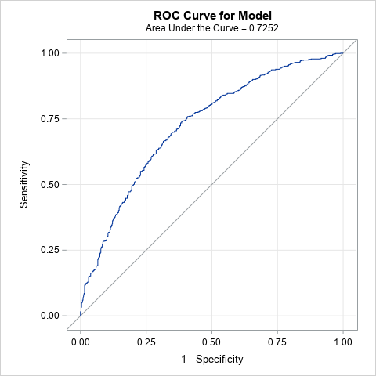  Model without interaction terms  N of IPTW cohort =  C statistics = 0.7252  Hosmer and Lemeshow Goodness-of-Fit Test P = 0.8742  Obs VarName Stddiff  1 age_cat2  2 race2  3 insurance2  4 income  5 BMI_cat  6 cdcc2  7 stage2  8 grade2  9 facility_location  10 facility_type  11 year_of_diagnosis_cat | 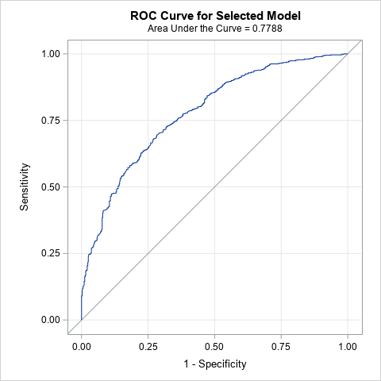  Model with any two-way interaction terms and significant level of stay at 0.2  N of IPTW cohort =  C statistics = 0.7788  Hosmer and Lemeshow Goodness-of-Fit Test P = 0.8311  Obs VarName Stddiff  1 age_cat2  2 race2  3 insurance2  4 income  5 BMI_cat  6 cdcc2  7 stage2  8 grade2  9 facility_location  10 facility_type  11 year_of_diagnosis_cat
Interpretation for which model to choose:

Requirement 2 Example: Table 1 from for PS IPTW cohort (ATE or ATT)
 | PS IPTW Cohort (N=2555) |  |  |  | P-Values | Standardized difference
 | Surgery No |  | surgery Yes
 | N | % | N | %
Total | XXX |  | XXX
age_cat2 | 251 | 20.2 | 248 | 18.9 | 0.7479 | 0.0411
41-59
60-69 | 623 | 50.2 | 686 | 52.2
70-79 | 322 | 26 | 332 | 25.2
80-89 | 44 | 3.6 | 48 | 3.7
race2 | .  775 | .  62.4 | .  820 | .  62.4 | 0.4644 | 0.0501
White
Black | 277 | 22.3 | 291 | 22.1
Other | 105 | 8.4 | 96 | 7.3
Unknown | 85 | 6.8 | 108 | 8.2
insurance2 | .  519 | .  41.8 | .  577 | .  43.9 | 0.3173 | 0.0498
Private Insurance
Medicaid/No insured | 95 | 7.6 | 97 | 7.3
Medicare | 597 | 48.1 | 620 | 47.2
Other/Unknown | 30 | 2.5 | 20 | 1.5
income | .  192 | .  15.5 | .  203 | .  15.5 | 0.9981 | 0
< $30,000
$30,000 - $35,999 | 191 | 15.4 | 203 | 15.4
$36,000 - $45,999 | 310 | 25 | 326 | 24.8
$46,000 + | 518 | 41.7 | 553 | 42.1
Unknown | 30 | 2.4 | 30 | 2.3
BMI_cat | .  935 | .  75.4 | .  982 | .  74.7 | 0.6916 | -0.0157
Normal(<25.0)
Overweight(25.0-29.9) | 306 | 24.6 | 333 | 25.3
cdcc2 | .  916 | .  73.8 | .  948 | .  72.1 | 0.2833 | 0.0745
0
>=1 | 238 | 19.1 | 252 | 19.2
Unknown | 87 | 7 | 114 | 8.7
stage2 | .  903 | .  72.7 | .  940 | .  71.6 | 0.5045 | -0.0264
I
II | 338 | 27.3 | 374 | 28.4
grade2 | .  96 | .  7.7 | .  93 | .  7.1 | 0.7593 | 0.0384
Well/Moderate
Poorly | 879 | 70.9 | 946 | 72
Unknown | 266 | 21.4 | 275 | 20.9
facility_location | .  458 | .  36.9 | .  505 | .  38.5 | 0.5625 | 0.0449
Eastern
South | 256 | 20.7 | 283 | 21.5
Midwest | 390 | 31.4 | 400 | 30.4
West | 137 | 11 | 126 | 9.6
facility_type | .  572 | .  46.1 | .  594 | .  45.2 | 0.6506 | 0.0179
Non-Academic program
Academic/Research Program | 669 | 53.9 | 720 | 54.8
year_of_diagnosis_cat | .  213 | .  17.2 | .  242 | .  18.4 | 0.8192 | 0.0415
1998-2004
2005-2007 | 312 | 25.2 | 316 | 24
2008-2009 | 270 | 21.7 | 282 | 21.4
2010-2011 | 446 | 35.9 | 475 | 36.2

Requirement 3. Example (ATE or ATT):

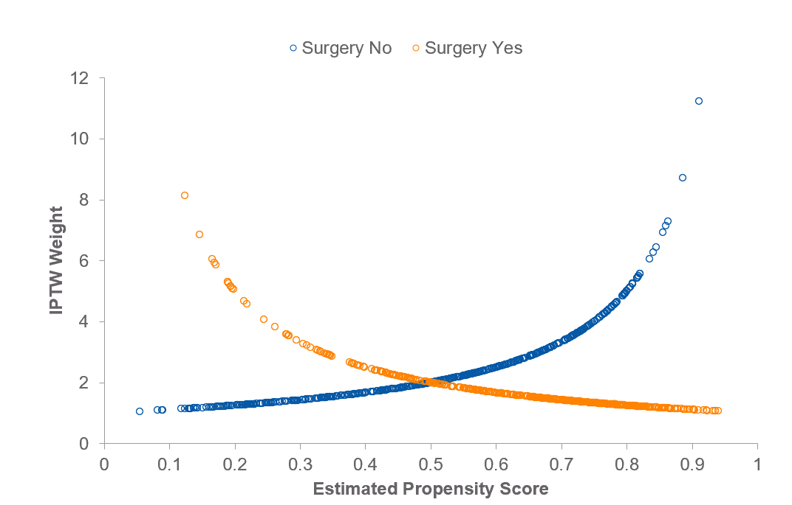
Requirement 4 Example: Table 2 – unadjusted estimate, adjusted estimate from regression modes, adjusted estimate from PS Matched, adjusted estimate from PS IPTW
 |  |  | ORs (95%CI)
 | Dead = 0 | Dead = 1
Surgery
No | 394(76.2) | 123(23.8) | Referent
Yes | 695(90.1) | 76(9.9)
Unadjusted ORs |  |  | 0.35(0.26-0.48)
Adjusted ORs
Multivariable model based on Science (including all covariates in the literature review and DAG, not required for HW 3) |  |  | 0.52 (0.36-0.74)
Multivariable model Purposeful Selection |  |  | 0.50 (0.36-0.71)
PS Matched |  |  | 0.52 (0.35-0.78)
PS IPTW ATE |  |  | 0.54 (0.38-0.76)

